**ST JOSEPH OF NAZARETH HIGH SCHOOL KAVULE-MPIGI**

**535/3**

**PHYSICS**

**PRACTICAL**

**Paper 3**

**MARCH 2017**

***2 ¼ hours***

**PRE-REGISTRATION EXAM**

**Uganda Certificate of Education**

PHYSICS PRACTICAL

**Paper 3**

2hours: 15 minutes

INSTRUCTIONS TO CANDIDATES:

*Answer ALL* ***questionS****.*

*Candidates are* ***no****t allowed to use the apparatus or write for the first 15 minutes.*

*Graph papers are provided.*

*Mathematical tables and non programmable calculators may be used*

*Candidates are expected to record on their all their observations as these observations are made and to plan presentation of records so that its not necessary to make a fair copy of them.*

*Details of the question paper should not be represented in the answer, nor is the theory of the experiment required unless specifically asked for. Candidates should however, record any special precautions they have taken and any particular feature of their method of going about the experiment.*

*Marks are given mainly for a clear record of the observations actually made, for their suitability and accuracy, and for the use made of them.*

1. In this experiment you will determine a constant θ of the spring provided.

1. Clamp the given spring provided as shown in the figure below.

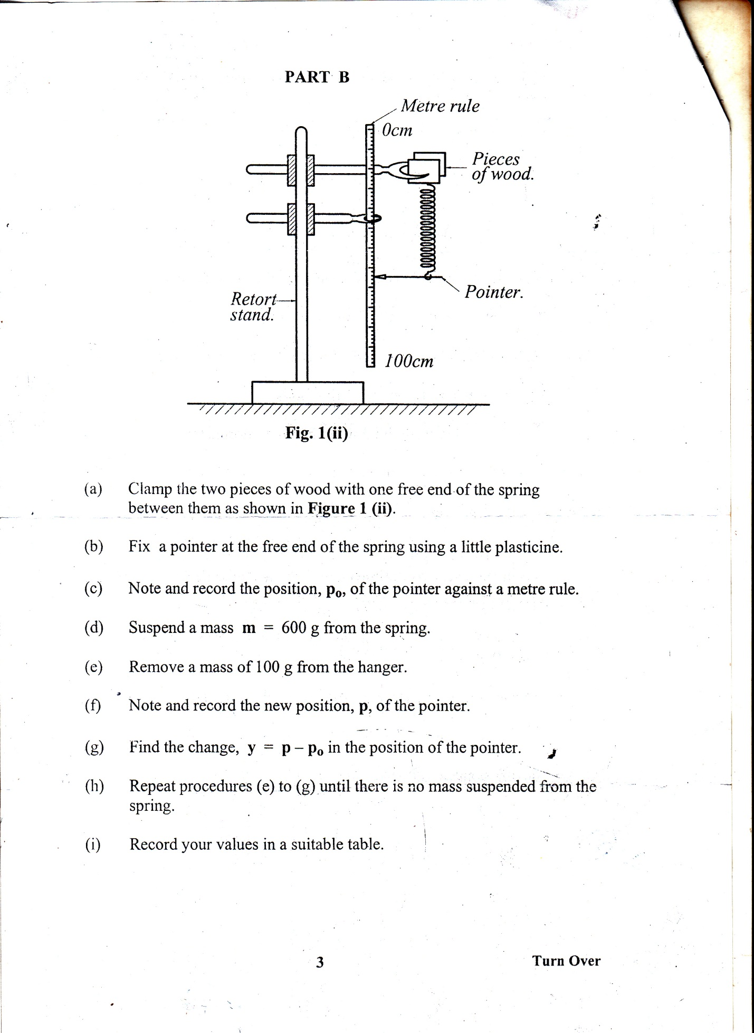

**L0**

(b) Measure the un stretched length **L0** when the spring is unloaded.

(c) Add a mass m = 0.050kg on the spring, measure and record the new length

L of the spring in metres.

(d) Repeat procedures (c) for m = 0.100, 0.150, 0.200, 0.250 and 0.300kg.

(e) Record your results in a suitable table.

(f) Plot a graph of L against m.

(g)From your graph find the value of m for which L = 2L0. Call this value m1.

(h)Unload the spring, suspend a mass w = 0.200kg from the spring.

(i) Pull the mass downwards through a small distance and release it to oscillate

vertically.

(j) Measure and record the time, t, for 20 oscillations.

(k) Calculate period **T** time for one oscillation

(l) Find the value of θ from the expression  .

**2. In this experiment, you will determine the refractive index of a glass block.**

1. Place a white sheet of paper on the soft board
2. Place the glass block on the white sheet of paper with its broad face top most.
3. Trace the outline

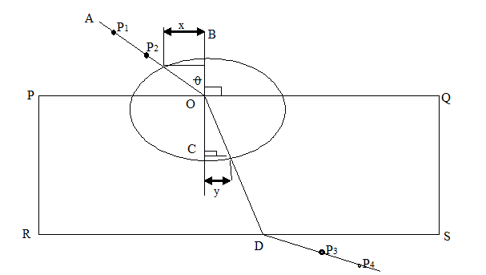

1. Remove the glass block and then label the outline PQRS as shown in the figure above.
2. Draw BC normal to PQ at O
3. Draw a line AO making an angle θ of 200 with BC.
4. Fix pins P1 and P2 vertical on AO
5. Place the glass block on its outline
6. Looking through the glass block from the side SR, fix pins P3 and P4 such that they appear to be in line with P1 and P2
7. Remove the glass block and the pins
8. Draw a line through P3 and P4 to meet SR at D.
9. Join O to D
10. Repeat the procedures (f) to (i) for the values of θ = 300, 400, 500, and 600
11. With O as the center, draw a circle of radius 4cm
12. From the intersection of AO and OD with the circle, draw perpendicular to BC
13. Measure and record the perpendicular distances x and y for each of the values of θ
14. Plot a graph of x against y.
15. Find the slope n of the graph

**HAND IN YOUR TRACING PAPER**

**CONFIDENTIAL FO PRE-REGISTRATION- 2017**

1. Apparatus

1-a soft board,

1. sheet of paper,

4- optical pins

5- a mathematical set.

**2. Apparatus**

1 retort stand

1 spring,

a metre rule,

6 masses @ 100g

stop clock/watch.